Oyster Task Force Meeting

Tuesday, November 19, 2024, 10:00am

New Orleans Lakefront Airport

6001 Stars and Stripes Blvd.

New Orleans, LA

**I.** Pledge of Allegiance

**II.** Roll call and introduction of guests

**Voting Members Present:**

Dan Coulon

Jakov Jurisic

Mitch Jurisich

Brad Robin

Brandt Lafrance

Al Sunseri

Sam Slavich

Peter Vujnovich

**Voting Members Absent:**

Shane Bagala

Brandon Debarge

Matthew Slavich

Willie Daisy

Steve Pollock

**Non-Voting Members Present:**

Robert Caballero

Austin Landry in for Davis Madere

Kyle Balkum

Brian Lezina

**Non-Voting Member Absent:**

**III.** Brad Robin motioned to approve the October 1, 2024 meeting minutes as presented, 2nd by Peter Vujnovich. Motion carries.

Brad Robin motioned to amend the agenda by adding an item under New Business, “D. To Consider Funding for Travel for Chefs and BMF Staff to travel to Washington, D.C. to participate in the Let the World Be Your Oyster Event”, 2nd by Sam Slavich. Motion carries.

Brad Robin motioned to accept the agenda as amended, 2nd by Peter Vujnovich. Motion carries.

**IV.** Treasury Report

Remaining Fund Balance- $537,995

Remaining Budget Balance- $68,946

Brad Robin motioned to approve the treasury report as presented, 2nd by Peter Vujnovich. Motion carries.

**V.** Committee Reports

A. Public Private Oyster Seed Grounds Committee- no report

B. Enforcement

September 21st- November 3rd 2024

**Region 4** (Iberia)

**Region 5** (Calcasieu, Cameron, Vermillion)

Cameron

**Seizures:**

Vermillion

**Seizures**

**Region 6**: (Terrebonne, Lafourche, Grand Isle)

Terrebonne

2- 56:424 unlawfully take oysters from state water bottoms.

3- 40:4A violate sanitation code (log Book)

**Seizures:**

32 sacks of oysters

**Region 8**: (Jefferson, Plaquemines, St. Bernard, Orleans)

**St. Bernard**

1-RS 56: 433.1 – Violate Seed Ground Vessel Permit Regulations (No Vessel Seed Ground Gear permit in possession).

1-RS 56: 433.1 – Violate Seed Ground Vessel Permit Regulations (1 Seed Ground Gear Permit/2 Scrapers).

1-RS 56: 433.1 - Violate Seed Ground Vessel Permit Regulations (No Vessel Seed Ground Gear Permit In possession).

1-RS 56: 433.1 – Violate Seed Ground Vessel Permit Regulations (1 Seed Ground Gear Permit/2 Scrapers).

2-RS 56:433.1 –Violate Seed Ground Vessel Permit Regulations (No Seed Ground Vessel Permit and No Vessel Seed Ground Gear Permit with 2 scrapers).

1-RS 56:433.1 – Violate Seed Ground Vessel Permit Regulations (No Seed Ground Gear Permit in possession).

1-RS 40:4 A – Violate Sanitation Code (Refrigeration).

1-RS 56: 433.1 – Violate Seed Ground Vessel Permit Regulations (No Seed Ground Gear Permit)

**Seizures:**

246- Sacks seized in connection with these violations and returned to water.

**Plaquemines**

1-RS 56: 424 E (1) – Taking Oysters from Unapproved Area.

1-RS 56: 424 A - Unlawfully take Oysters from State Waters.

1-RS 56:31.1 – Fishing under Revocation or suspension.

**Seizures:**

2 – Sacks seized in connection with these violations and returned to water.

**Jefferson**

1-RS 40: 4 A – Violate Sanitation Code (Refrigeration)

1-RS 40: 4 A- Violate Sanitation Code (Logbook)

**Seizures:**

75- Sacks seized in connection with these violations and returned to water.

Harvesters gear permit, scraper license but also need gear license for public seed ground permit

Jakov Jurisic motioned to request that when LDWF send out the annual letter for licenses and renewals that they attach a letter reminding oystermen who hold retainer licenses that they will still need to purchase gear licenses if they intend to go out and fish, 2nd by Brad Robin. Motion carries.

C. Legislative Committee- no report

D. Legal Committee- no report

E. Research Committee- Earl Melancon stated that the State of the Coast Conference is coming up in May 2025, asked the task force if they would like to participate in an oyster panel at the conference, the task force stated they would like to participate, Research to call a committee meeting prior to the next OTF meeting to discuss panel topics, LFF Mini- Summit

F. Coastal Restoration Committee- George Ricks announced two upcoming meetings that he urged the oyster industry to attend/ participate in:

* **The Senate Transportation, Highways and Public Works Committee**

**Thursday, November 21, 2024 for 8:00am in Room E**

The committee is planning to receive an update from CPRA on the Mid-Barataria Sediment Diversion Project and related issues and receive public comment. *Persons who do not feel comfortable giving testimony in person may submit statement in accordance with Senate rule 13.79, in lieu of appearing before the committee. Statements may be emailed to [sthpw@legis.la.gov](mailto:sthpw@legis.la.gov) and must be received by the committee secretary at least four hours prior to the meeting to be included in the record for this meeting.

* **CIAC Meeting**

**Wednesday, December 11, 2024, 9:00-10:30am**

**Southeast Flood Protection Authority, East Office**

**6920 Franklin Ave. New Orleans, LA 70122**

G. Marketing Committee- Anna Koehl stated that more information is to come from GNO Inc regarding the February 6th super bowl events

H. Health Committee- Jen Armentor stated that the Health Committee held a meeting on Tuesday, October 29, 2024, the committee discussed on-boat cooler log regulations and the request to no longer be required to take internal meat temperatures; working with the FDA on a sample process study, seems like it will be approved, if approved a yearly, validated process study will be accepted in lieu of having to take internal meat temperatures, each individual seeking to take advantage of this option would have to complete a process study on a yearly basis, prior to vibrio season

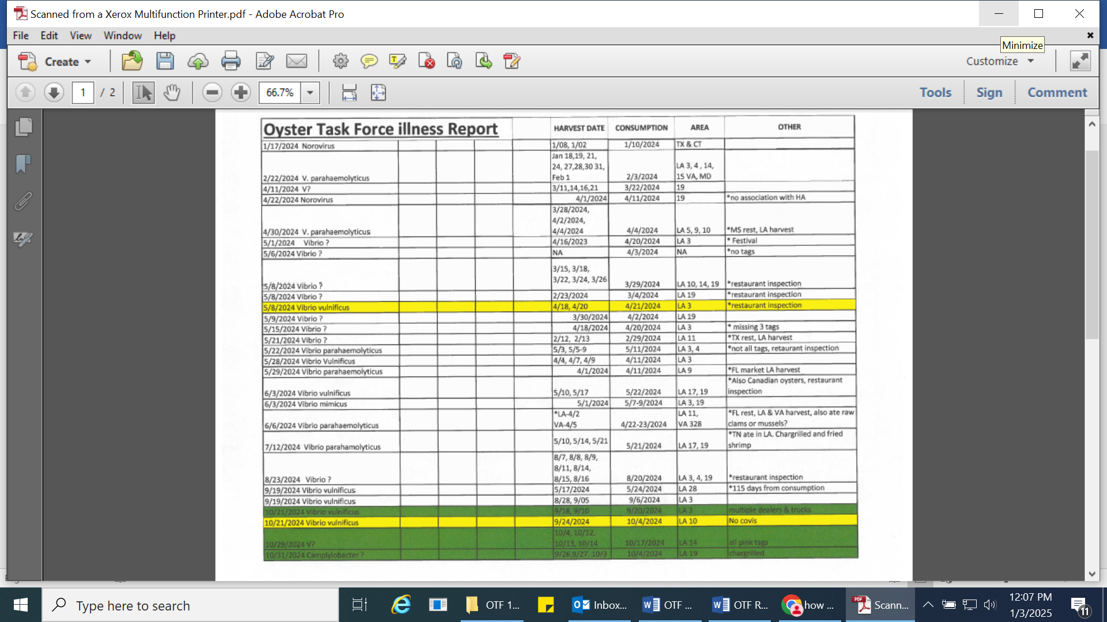

I. Aquaculture Committee- no report

J. Joint Task Force Working Group- no report

**VI.** New Business

1. Robert Caballero provided the task force with an oyster season update

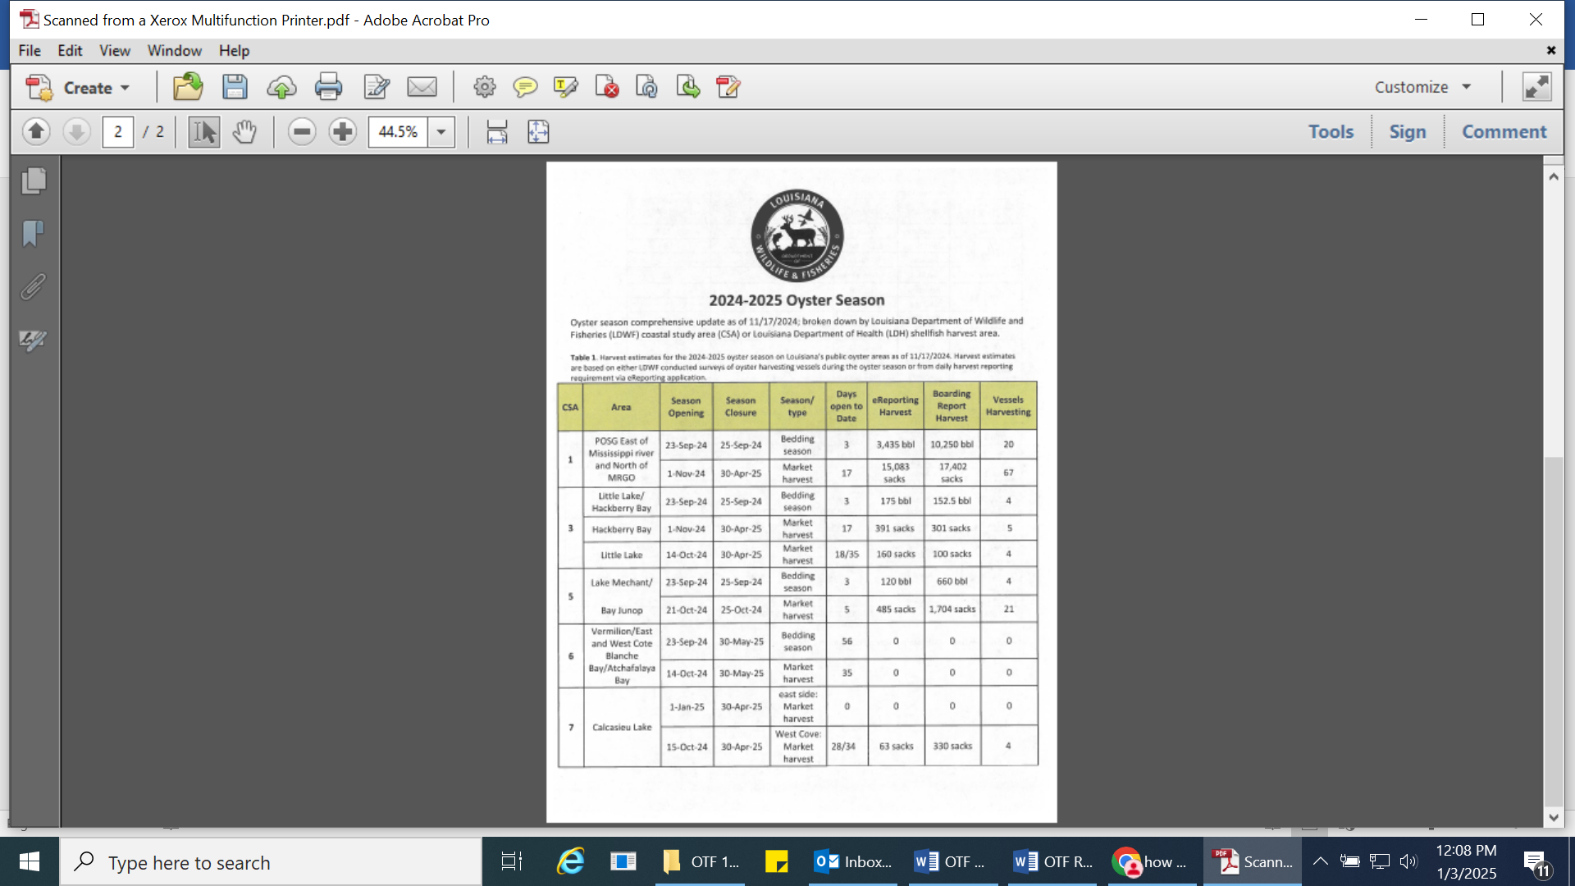

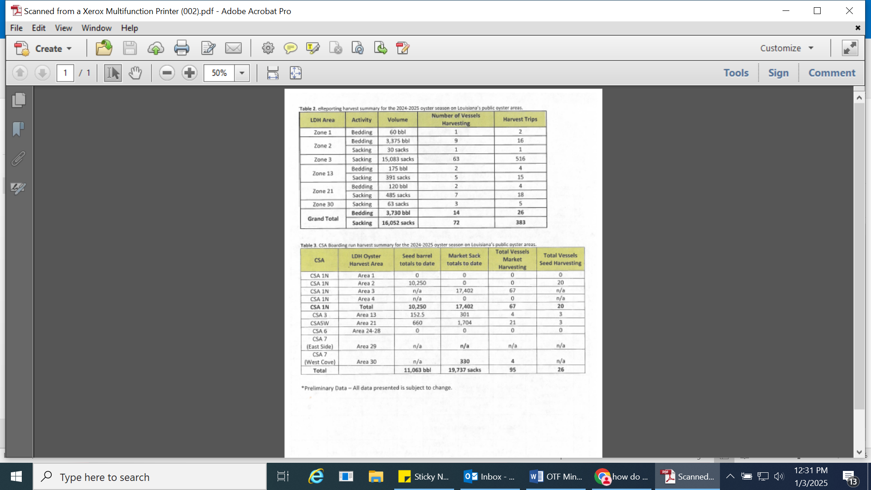

1. Anna Koehl provided an update on the Let the World Be Your Oyster event, invite list has been finalized, would like to send the save the date out before Thanksgiving and the mailer the first week after Thanksgiving, received a $10,000 sponsorship for the event from Venture Global; finalizing chefs for the event, the event will take place at Dauphines in Washington, D.C. from 6-8pm, started working on a white paper for congressional meetings
2. 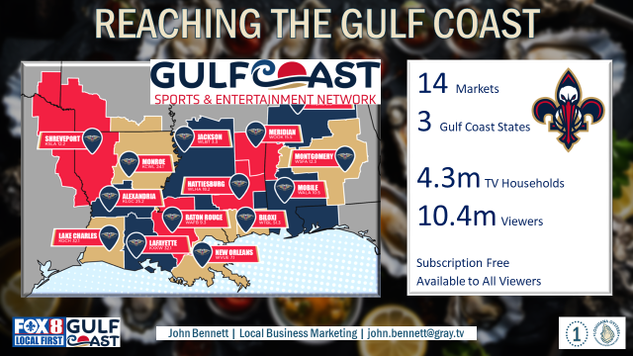



Al Sunseri stated that in the past they hosted an event during legislative session in Baton Rouge, if the task force is interested in hosting this event again, it would be worth while to reach out to the other task forces and see if they would be on board

1. Brad Robin motioned to approve funding for travel for chefs and BMF staff to travel to Washington, D.C. to participate in the Let the World Be Your Oyster event, 2nd by Peter Vujnovich. Motion carries.

**VII.** Public Comment

Chris Schieble introduced Christian Winslow as the new Director of Marine

**VIII.** The next OTF meeting was set for Wednesday, January 8, 2025 for 10:00am at the New Orleans Lakefront Airport, the Research Committee plans to host a committee meeting prior for 9am.

**IX.** Brad Robin motioned to adjourn, 2nd by Peter Vujnovich. Motion carries.